FOR IMMEDIATE RELEASE United Infrared, Inc.

August, 2010 8472 Adams Farm Road
Greensboro, NC Randleman, NC 27317
888-722-6447

EquineIR™ to Provide Complimentary Infrared Scans for WEG Equine Athletes at the
2010 Alltech FEI World Equestrian Games in Lexington, KY

EquineIR™, the Official Vendor Partner of the 2010 Alltech FEI World Equestrian Games announces that they will be providing complimentary infrared scans including veterinary interpretation for any competing horse during the games. The decision was made in an effort to help bring awareness of Equine thermography and to demonstrate the benefits of infrared to the overall health and well-being of horses in general.

“We are extremely excited about our partnership with this prestigious organization and event and our free offer at the games,” states Peter Hopkins, co-founder of United Infrared, Inc. and director of EquineIR™. ”This service will greatly benefit the equine community and we are very proud to be able to showcase it in a big way at this world event,” he concludes. EquineIR™ (www.EquineIR.com) is a part of the United Infrared Network (www.UnitedInfrared.com) - an international network of certified and trained infrared thermographers performing infrared (IR) scans on three continents.

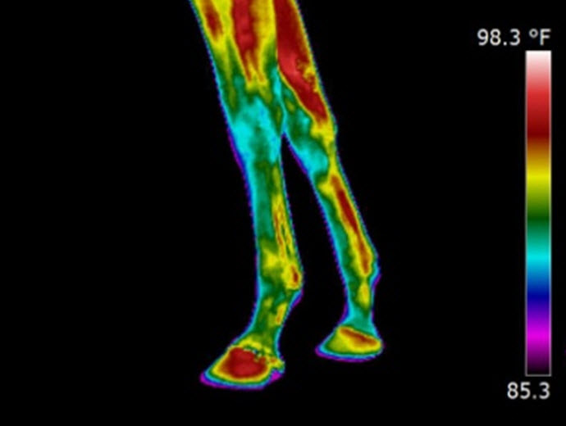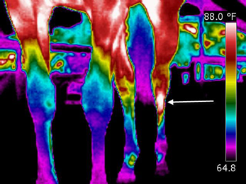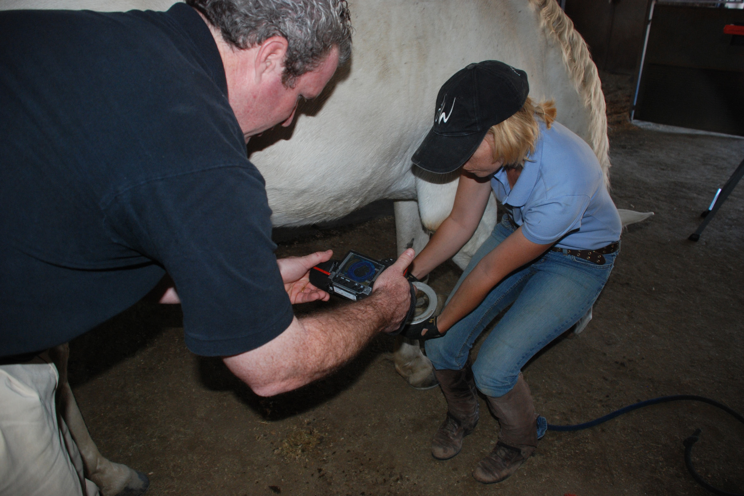
Infrared image of low limb of a racehorse Infrared Image of a cannon fracture IR thermographer performing a scan

WEG Athlete owners may contact EquineIR™ for scheduling via a special web address (www.equineir.com/weg), or coming to their booth at trade show pavilion (#524), or by calling toll free 888-722-6447. EquineIR™ will have certified technicians on-site to facilitate the scanning which will be done at the customer’s stable location. An infrared scan enables horse care professionals to determine the event readiness of their horse and to help identify any potential injuries in a completely safe and non-invasive manner. The World Equestrian Games (www.alltechfeigames.com) is the largest equestrian event in the world. In 2010, the games leave Europe for the first time and come to the United States to the Kentucky Horse Park in Lexington, KY. In addition to the eight world championships, the 2010 Alltech FEI World Equestrian Games will be a celebration of all things equestrian. The World Equestrian Games will represent an unprecedented opportunity for the equine industry to showcase itself, in a variety of ways, to spectators from around the globe.

“At the 1996 Olympic Games in Atlanta, where there were millions of dollars worth of equipment available to the equestrian teams, the most-requested diagnostic tool was thermography. It was fast. It was portable and it was non-invasive. It could detect injury sites before they became lameness problems, and could guide practitioners to specific anatomic areas for study using other diagnostic techniques. And it was extremely accurate when used by an experienced practitioner.” So says Brown, K. in Thermography: Diagnosis tool for horses, The Horse, Oct 2001, 490. “We are truly making a difference for the horses and the owners with equine thermography. Our members come in with a desire to learn how to take correct images, and leave with a newfound appreciation for the horse in sport,” states Dr. Joanna Robson, DVM and Technical Director for EquineIR™. “Standardization and proper education is imperative to the continued success of thermal imaging as an equine diagnostic modality.” Dr. Robson concludes.

“EquineIR™ is a service whose time has come,” states Greg Stockton, President of United Infrared, Inc. “By imaging the horse, even if no problems are found, a baseline of the heat patterns of the horse is created. If the horse becomes injured, the archived imagery can be compared the post-injury imagery enabling the vet to make a better diagnosis. We have become the world’s largest repository of IR images of horses, and this enables us to have thousands of IR images of various breeds and injuries available to the horse-diagnosing community”, concludes Mr. Stockton.

For information on the participation of EquineIR™ in the WEG games and the “Complete to Compete” campaign, please visit www.equineir.com/weg.

